Board Game Social Camp 2018 Schedule

Friday
4pm – Meet at Horseshoe Bay Ferry Terminal
6:30pm – Take Bus to Camp
7pm – Arrive at Camp Olave
7:00 to 7:30pm – Ice Breakers Games
7:30 to 10pm – Variety of Appetizers & Board Games
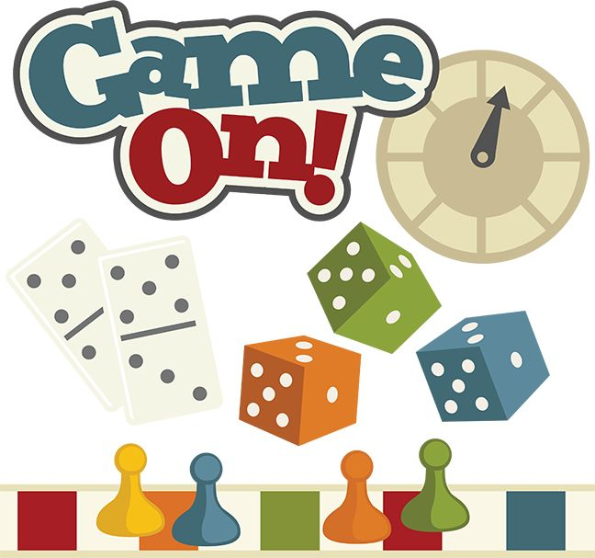
11pm – Bedtime

Saturday
9am – Wake Up
9:30 to 11:00am – Breakfast Buffet
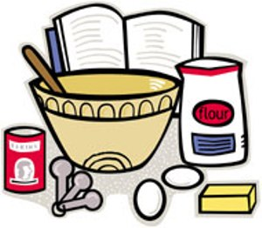
11am to 1pm – Game Show
1 to 2pm – Build your own Nacho Bar
2 to 6pm – Afternoon Options:
- Board Games
- Walk around the camp
- Homework
6 to 7:30pm – Full Roast Dinner with a load your own baked potato bar
7:30 to 9pm – Board Games
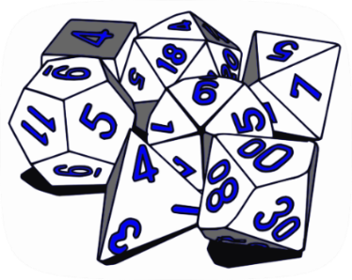
9 to 10:30pm – Night Games
11pm – Bed Time

Sunday
9am – Wake Up
9:30 to 10:30am – Breakfast Buffet & Make Bagged Lunch
10:30 to 11:30am – Clean the Cabin/ Snack
12:00 – Bus Pick-Up at Camp Olave
1:05pm – Ferry to Horseshoe Bay with Lunch on the Ferry
2:00pm – Pick-up at Horseshoe Bay Ferry Terminal

