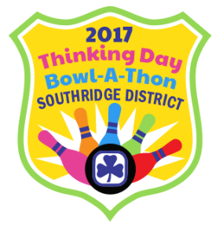
SOUTHRIDGE DISTRICT
Girl Guides of Canada
CWFF BOWL-A-THON FEBRUARY 19, 2017
The Canadian World Friendship Fund (CWFF) was established in 1945 for the promotion of Canadian Guiding throughout the world, as a contribution toward world peace and goodwill.
Name and phone no. of pledger | Pledge per pin | Flat rate pledge | Total  pledge
 |  | TOTAL | $

Please give pledges and pledge sheet to your leader no later than March 20th. Cheque should be made payable to Girl Guides of Canada.

Bowlers Name:_______________________
Bowler’s Unit:________________________

